Basic Questions (Any 8 out of 9)

1. How many unique students are there in the dataset?

Answer: There are total 2k unique students present in the dataset.

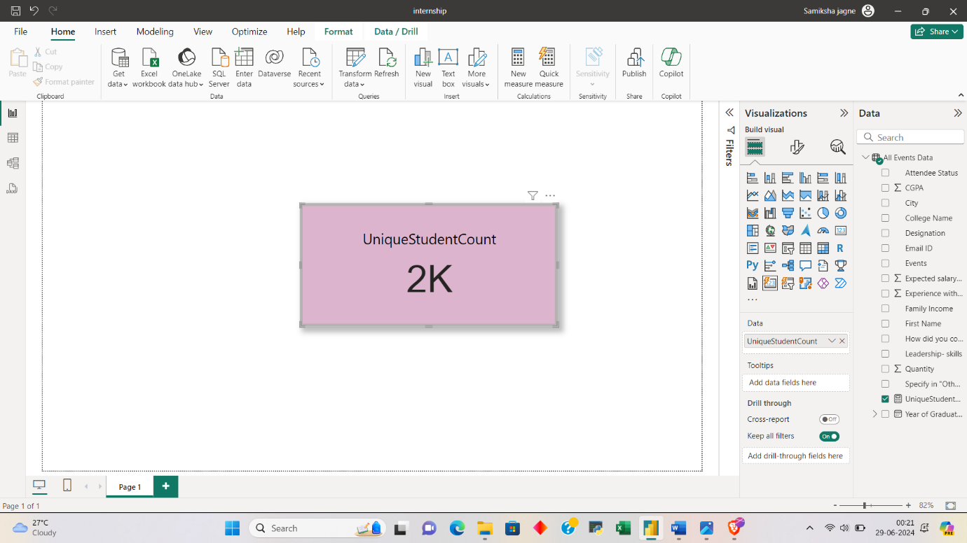

1. What is the average GPA of the students?

Answer : Average GPA of students is 8.04.

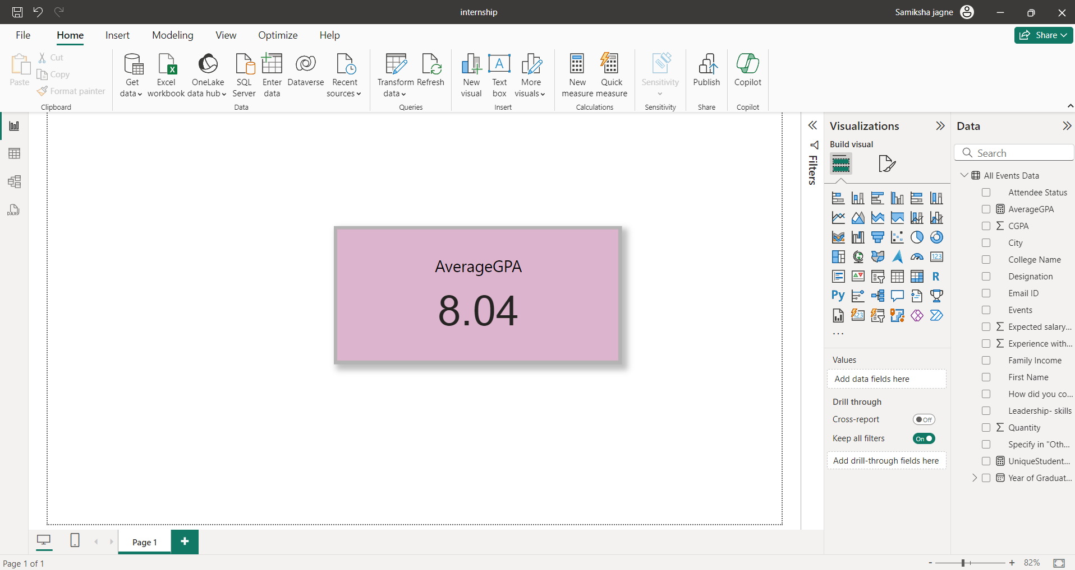

1. What is the distribution of students across different graduation years?

Answer:

1. What is the distribution of student’s experience with python programming?

Answer:

* 25% students have both 3 and 7 months of experience which is the highest count.
* 18.75% students have 5 months experience.
* 12.50% students have experience of both 4 and 8 months.
* 6.25% students have 6 moths of experience which is the lowest count.

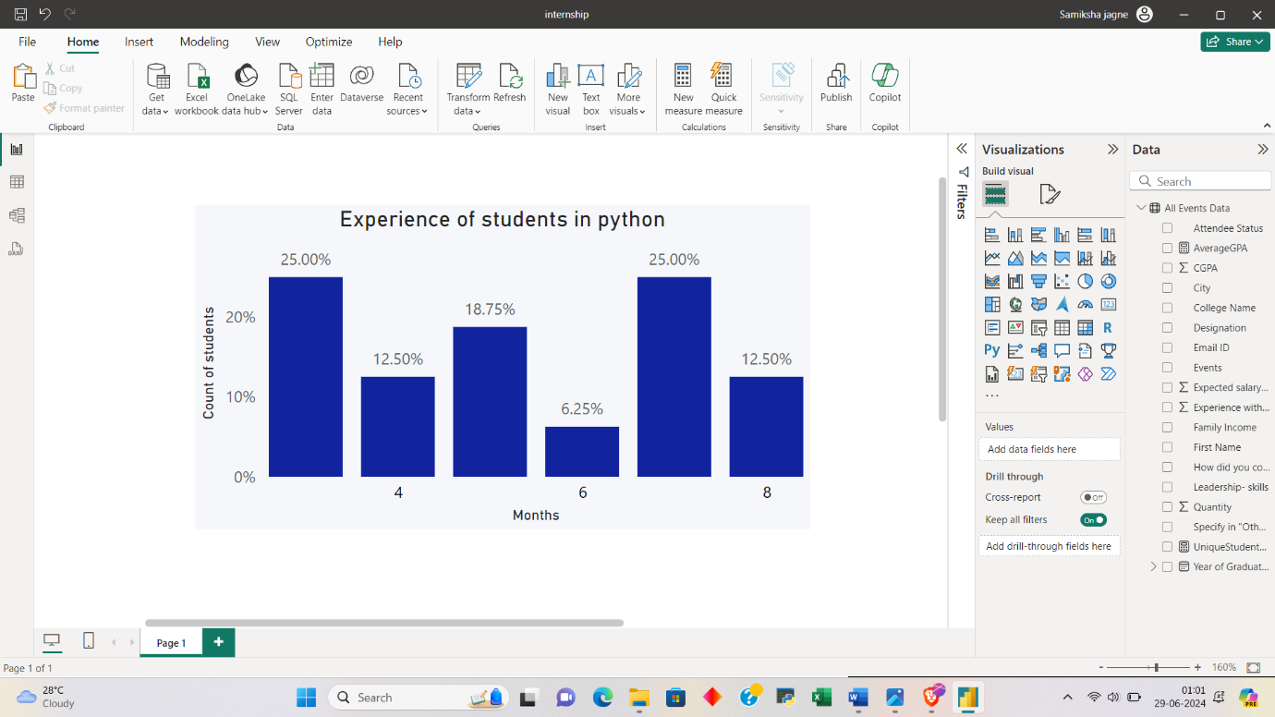

1. What is the average family income of the student?

Answer: Average family income of the student is 0-2 lakhs as 92% students have belong to this range of income.

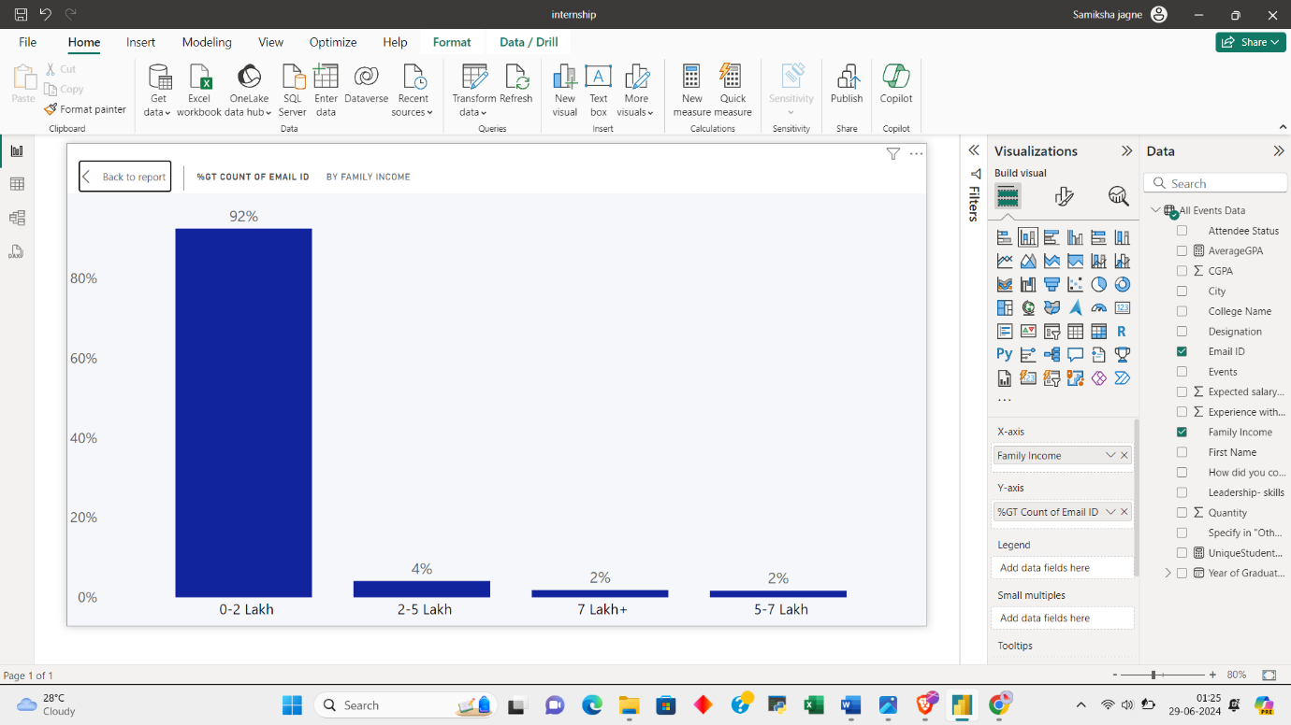

1. How does GPA vary among different colleges? (Show top 5 results only)

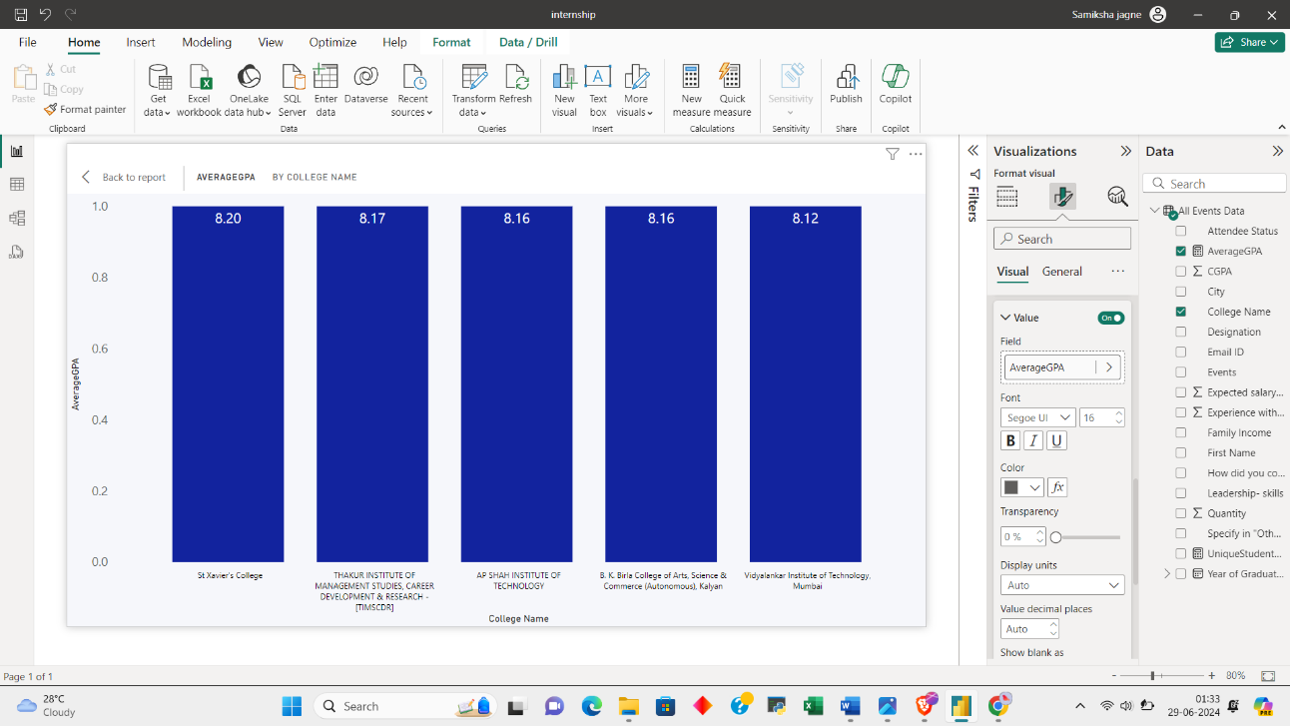Answer:

1. St.Xavier’s college – 8.20
2. Thakur Institute -8.17
3. A.P. Shah institute -8.16
4. B.K. birla college -8.16
5. Vidyalankar institute -8.12

7. What is average GPA for student from each city ?

Answer: Kolhapur has highest GPA i.e. 8.6 followed by Raipur, Sonipat,Gurugram ,Puri and Siwan with 8.5 GPA.

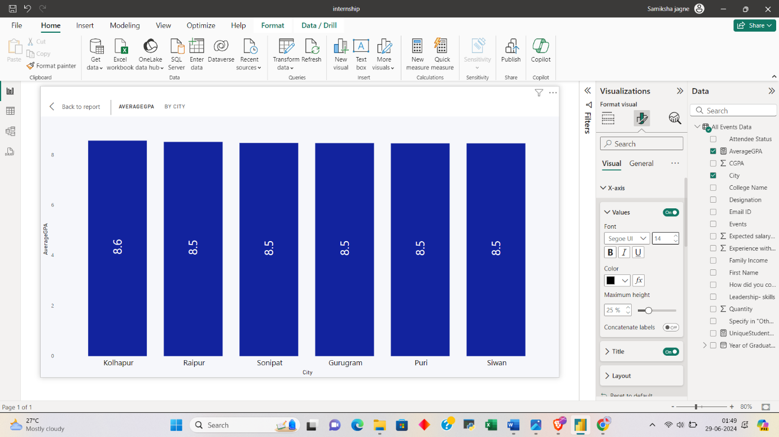

8. Can we identify any relationship between family income and GPA?

Answer:

Students with a family income of "0-2 Lakh" have an average GPA of around 8.034.

Students with a family income of "2-5 Lakh" have a slightly higher average GPA of approximately 8.115.

Students with a family income of "5-7 Lakh" have a lower average GPA of about 8.004.

Students with a family income of "7 Lakh+" have the highest average GPA of around 8.149.

There seems to be an inverse relationship between family income and average GPA, where students from higher income families tend to have slightly lower GPAs compared to those from lower income families.

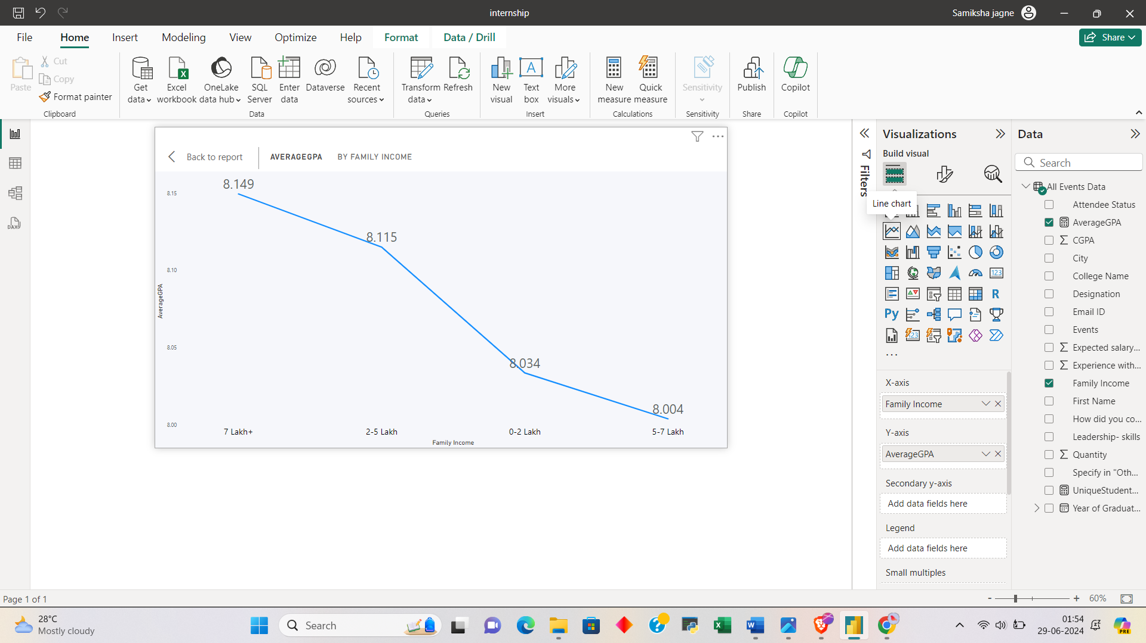

Moderate Questions (Any 8 out of 9)

1. How many students from various cities?

Answer: the list is very long as there are many cities so the data is exported as a csv file and submitted separately.

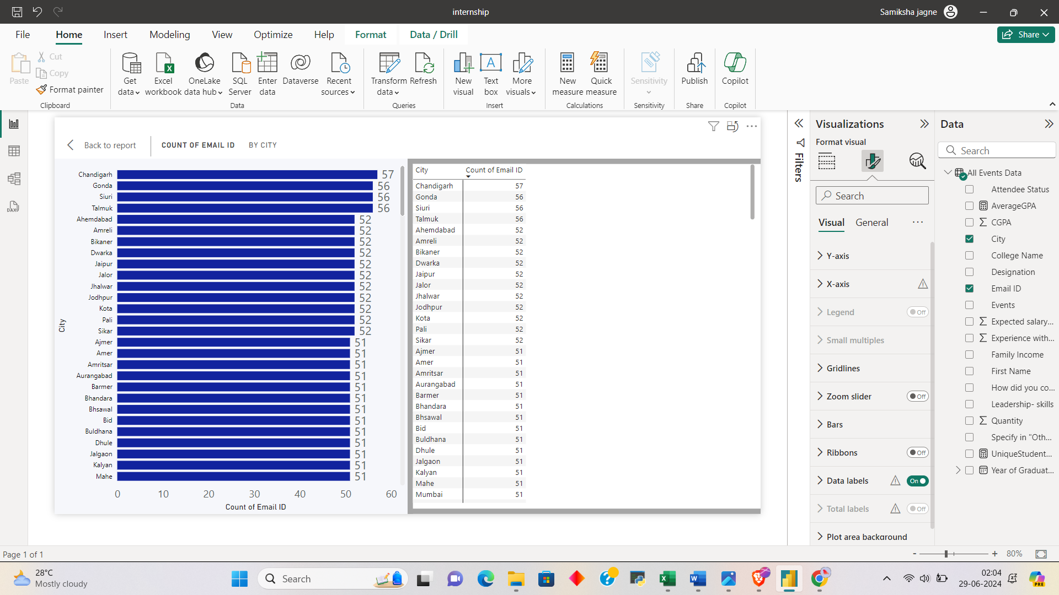

2. How does the expected salary varies based on factor like GPA, Family income, Experience in python (Months)?

Answer:

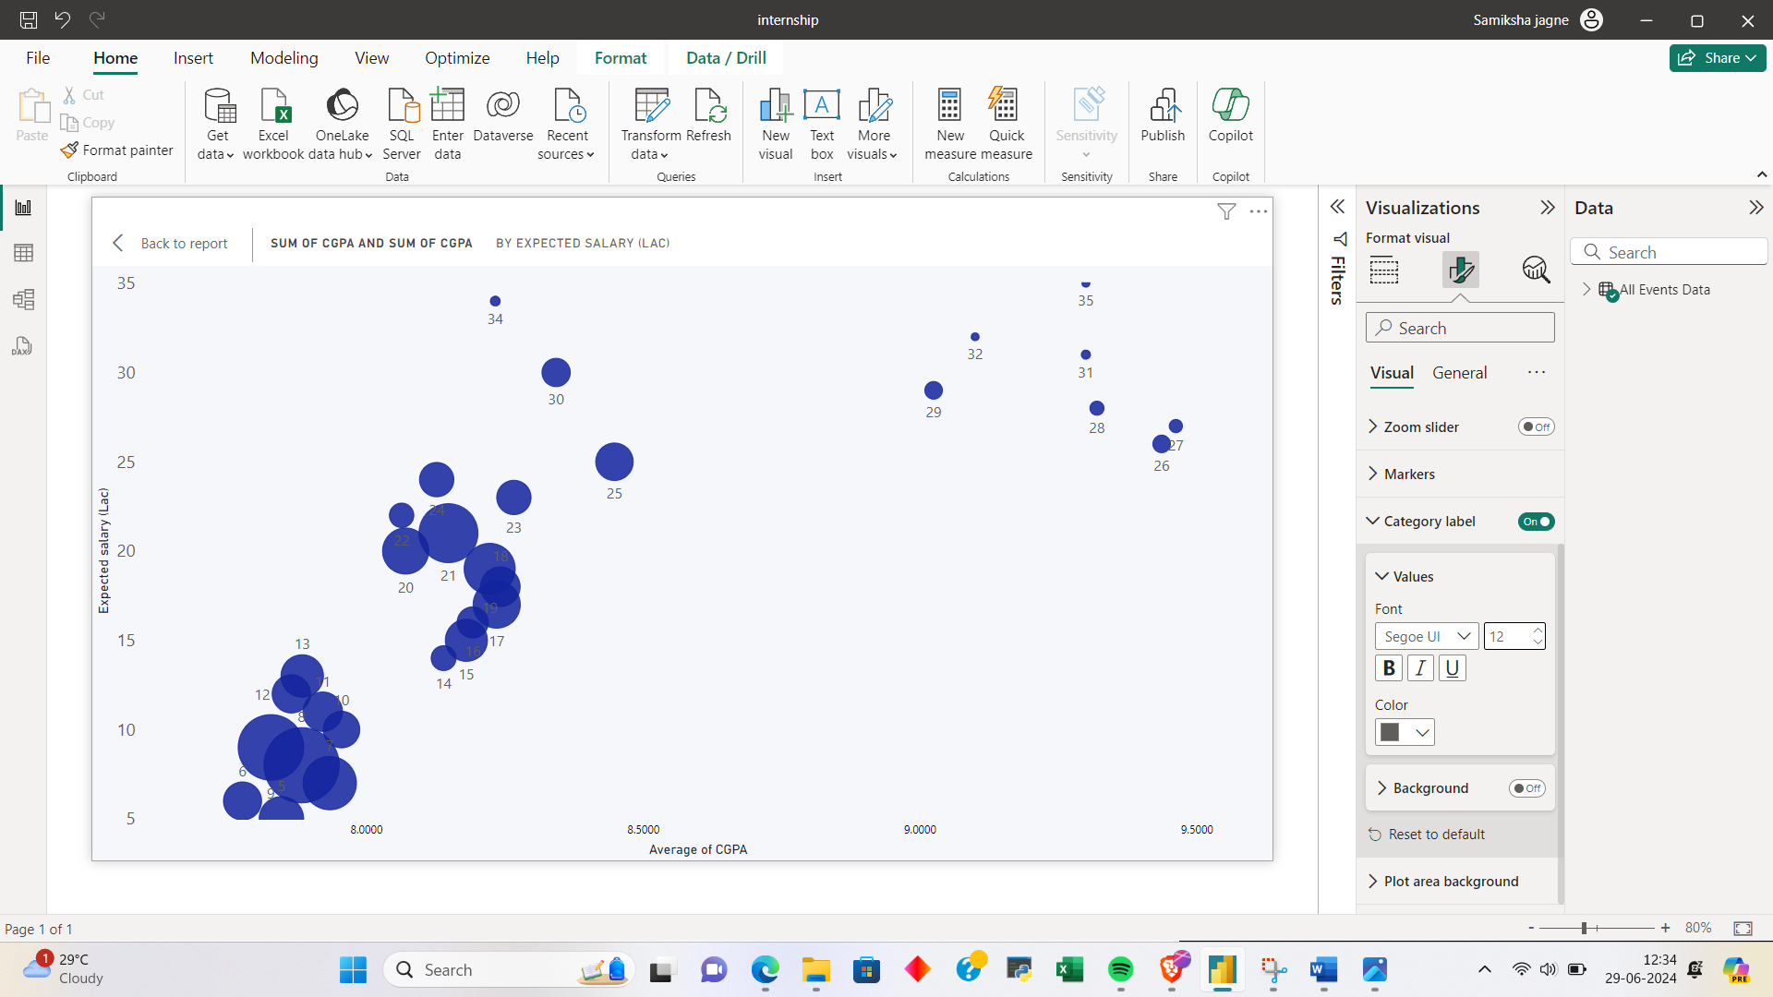

In this GPA Expected Salary graph it is observed that GPA and Expected salary of applicants are proportional , applicants with more GPA expects more salary.

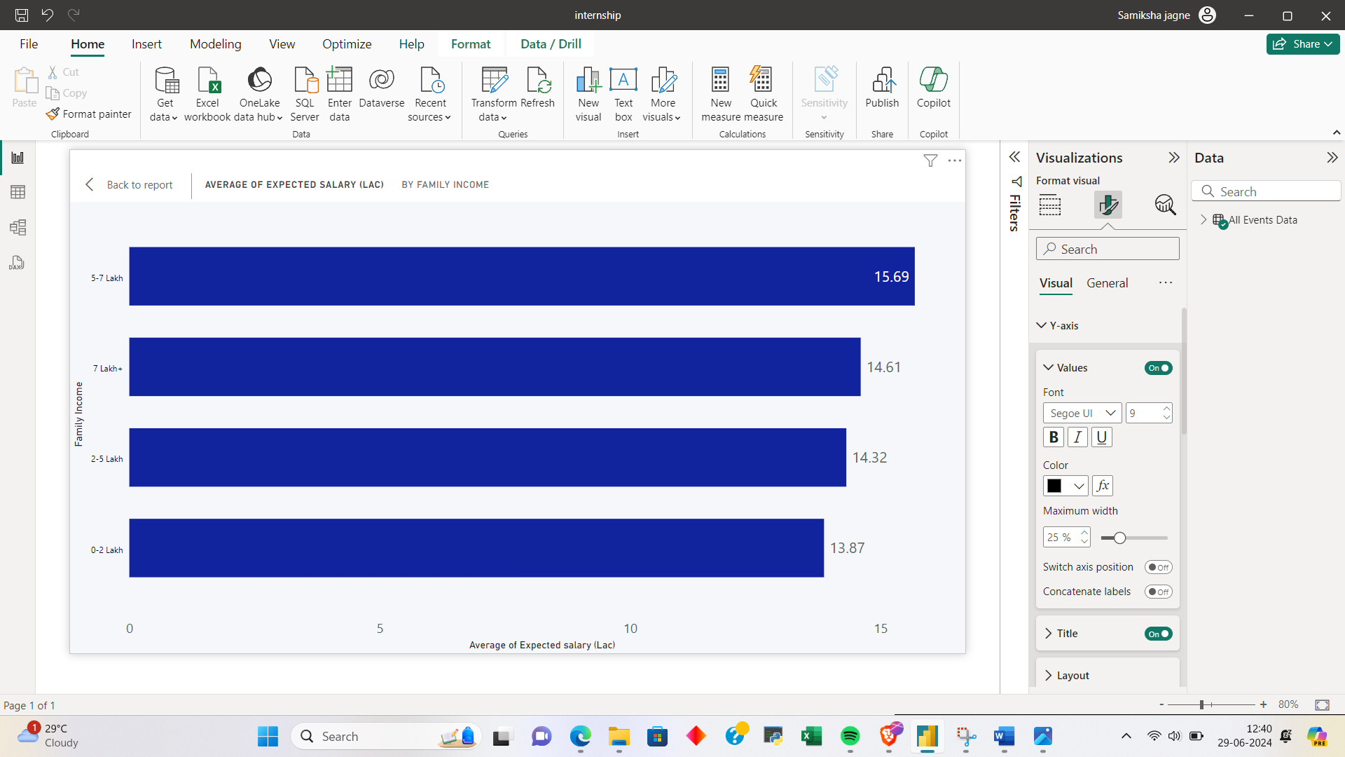

In this income vs expected salary graph it is observed that people between 0-5 lakh average income expect salary ranging from 13-14 LPA, and people between 5-7 lakh average income expect salary ranging from 14-15 LPA.

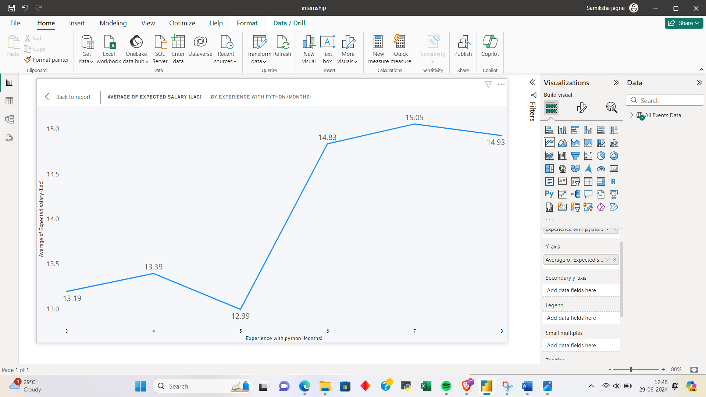

In this expected salary vs experience in python (months) graph it is analysed that people with more experience expect more salary.

3. Which event tend to attract more students from specific fields of study?

Answer:

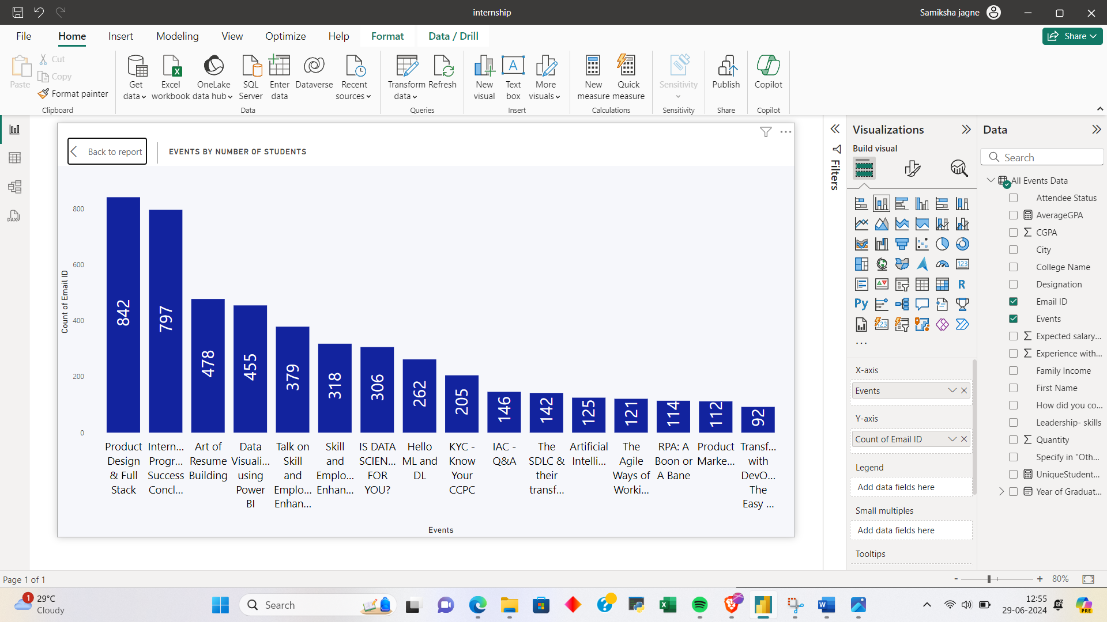

Events like Product design & full stack , IP Success Conclave attract more students with maximum count of 842 applicants attended Product design & full stack event followed by other events and mostly the attendees are students.

4.Do students in leadership positions during their college years tend to have higher GPAs or better expected salary?

Answer: it is observed that participating in leadership positions does not affect their GPAs but people with leadership experience expect better salary than those who did not .

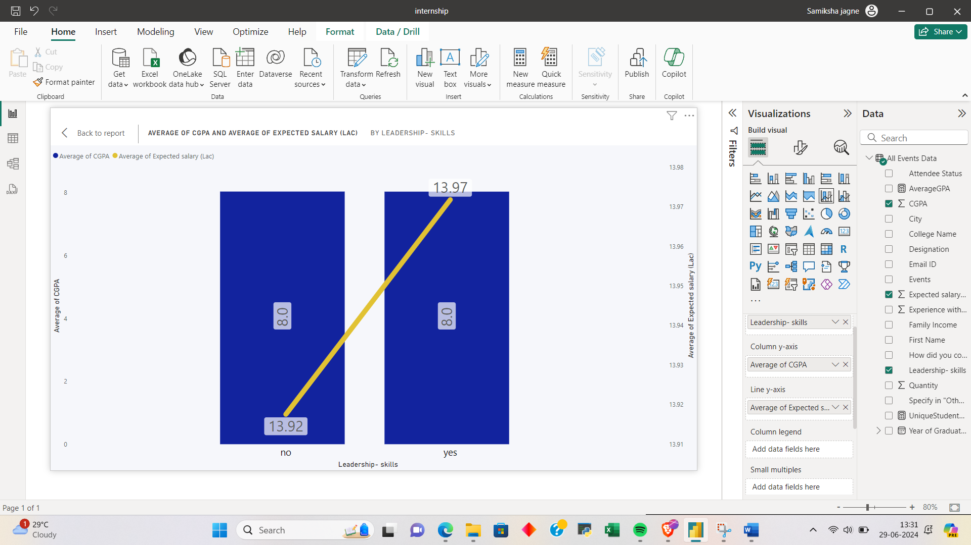

5. What promotion channel brings in more students participants in event?

Answer: Whatsapp bring most number of participants for the event.

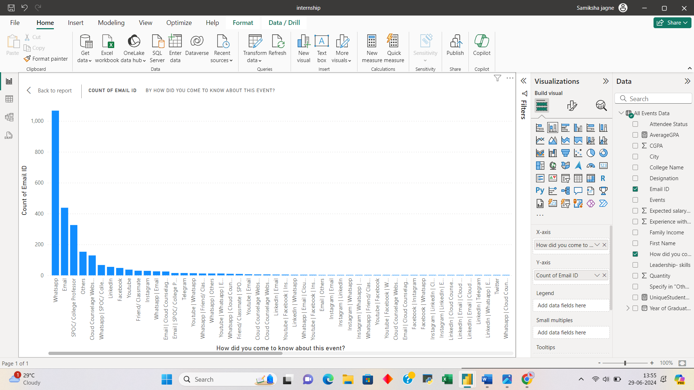

6. Find the total number of students who attended the events related to Data Science?

Answer: total 1023 students participated in events related to Data Science.

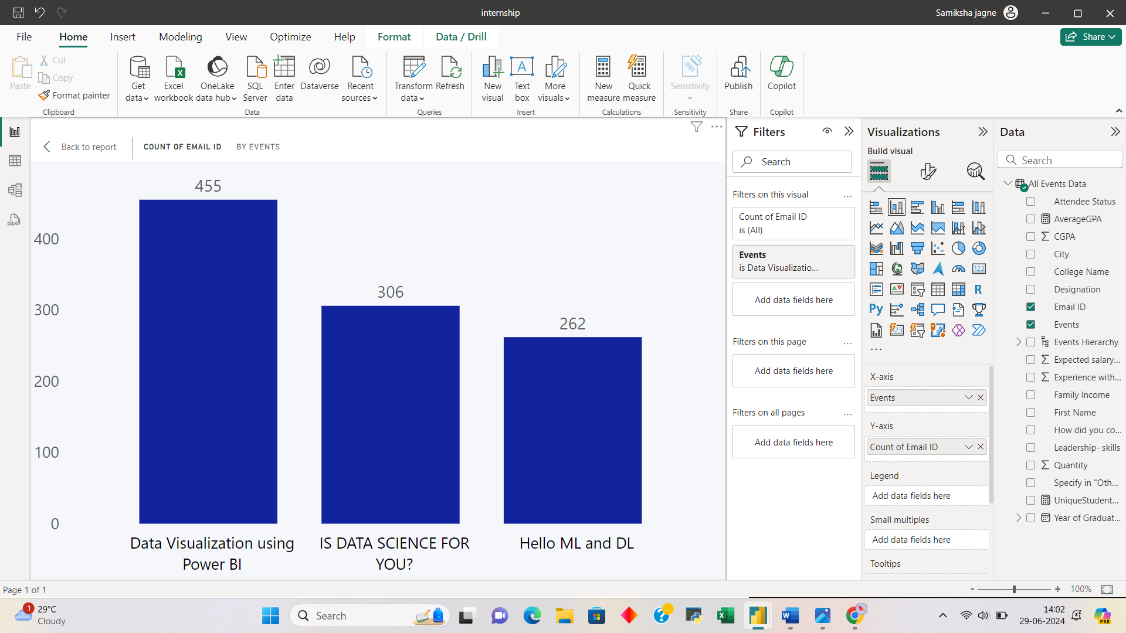

7. those who have high cgpa and more experience in language those who had high expectations for salary? (AVG)

Answer: this both the charts are the proof that students having more experience in language and higher CGPA expect high salary.

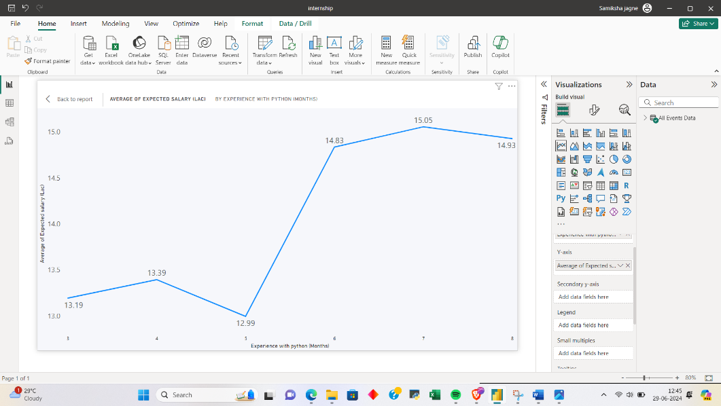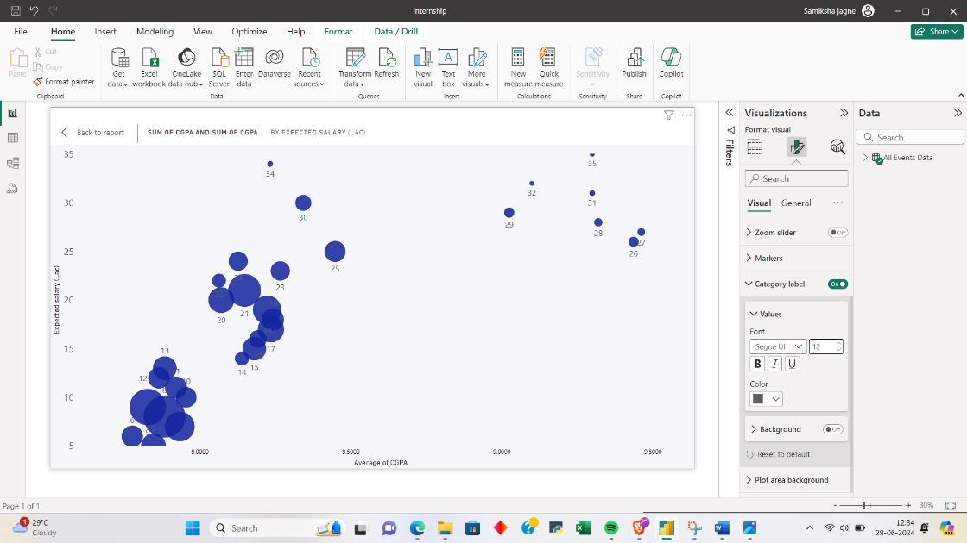

8. how many students know about the event from their college? Which of these Top 5 colleges?

Answer: 71 students came to know about the event from their college.

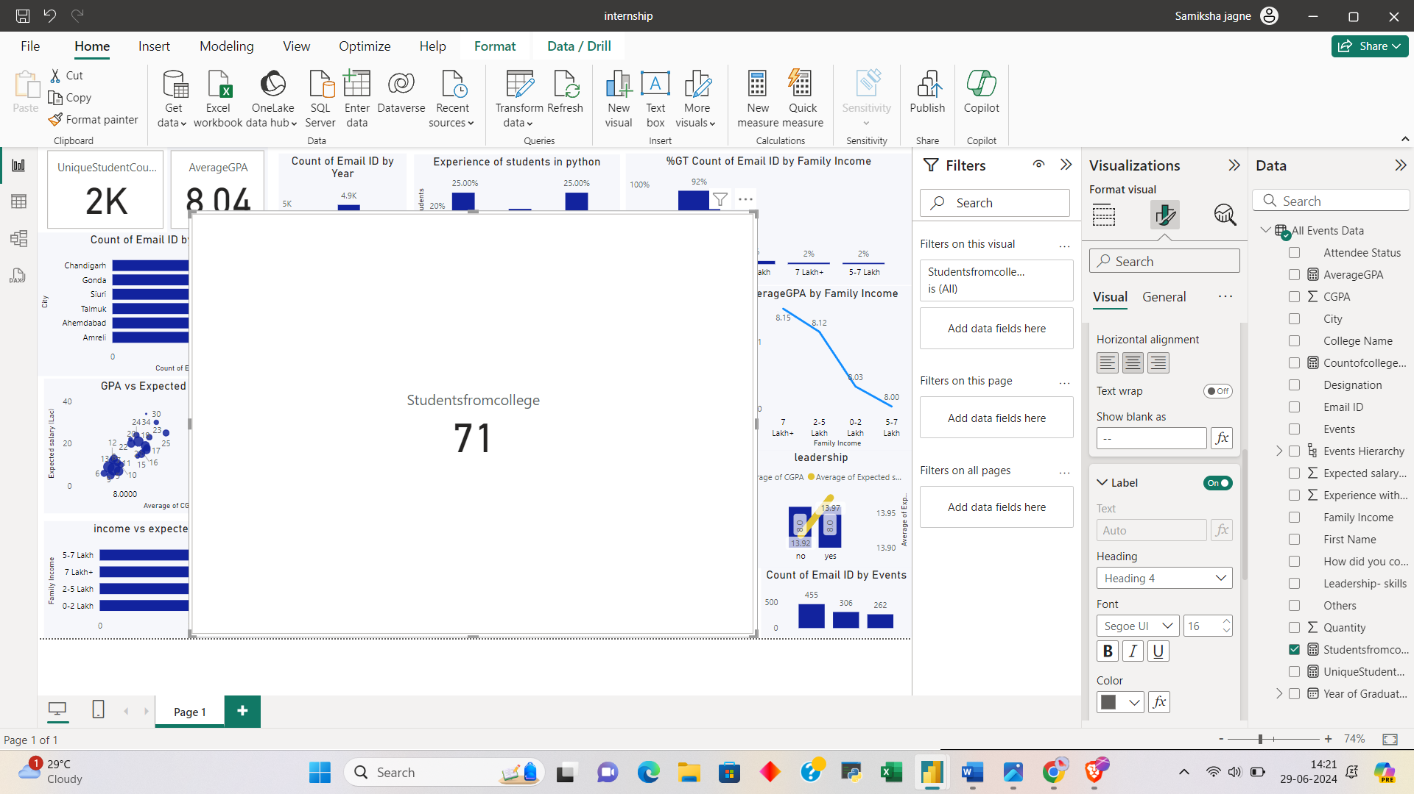

Top 5 colleges:

